***Environmental Solutions in Bowling Green, OH***

**How are nonprofits, governments, and independent players solving the climate problem?**

*Part 2, A Continuation of* [*Part 1*](https://falconbgsu-my.sharepoint.com/:w:/g/personal/gasserh_bgsu_edu/Eaqzju61qMZGloosE5JCQsgBmbkC3Bxw1D5TkMnsenCB6g?e=eBA9xK)*.*

*Potted plants and geode collection, Drain home window. By Heidi*

**This Paper = CRASH COURSE CLIMATE (again)**

***INTRODUCTION***

To build strength within the obvious cracks in national, Midwestern, Northwest Ohio’s, and the City of Bowling Green’s climate preparations, I identify a scale of micro necessities, and major systemic threats that must be addressed strategically in order to secure the longevity of a flourishing Earth status within our lifetimes. These needs have spurred innovative campaigns, and projects that force thoughtful participations. ***From private sector funding and public service thresholds, the options at hand begins with inventive solutions between issues and parties, continues with water in human-costing flooding surplus and capital-costing scarcity, and ends with opportune growth in Bowling Green.***

This installation largely commends the frameworks spearheaded by the Carbon Disclosure Project (CDP). I also rely heavily on digitally sourced materials, without traditional usage of academic journals. That way, these resources are accessible to readers of both academic prestige (without immediate awareness of said digital alternatives) and readers who deserved better than my offerings, extended kindly with but your browser’s search.

On Dec. 9th, I conducted a friendly interview with co-founders Rose and David Drain of Bowling Green Save Our Neighborhoods Group, otherwise known as “BG SONG” (Note: I am also a member of this organization). The Drains grew up in the Bowling Green Community; They partnered in 2003 and moved back to the area in 2019. Both possess resumes of volunteer, corporate, and formal educational experience. Rose officially served as the 2023 term President; David served as the 2023 Fundraising and Finance Committee Chair, and now fulfills SONG’s President and Interim Executive Director titles, until the budding organization secures funding for a permanent director. This secondary source interview investigates BG SONG as an organization, brief anecdotal histories from the Drain’s accounts, City politics, and informal expert perspective on my proposals from Part A of the Community Needs Review.

I end this review of Bowling Green Community Need with a continued proposal for Community Gardening, after I explain the importance of energy and water usage sensitivities, along with biodiversity harboring deeper, more promising implications beyond aesthetic enjoyments: symbiosis between flora, fauna, and peopled communities.

**Carbon Disclosure Project Framework, and Other Digital Supplementations**

***REVIEW OF “LITERATURE”***

Cited generously in [Part A,](https://falconbgsu-my.sharepoint.com/:f:/g/personal/gasserh_bgsu_edu/EuY8GB07MrhCq6Hs3k6EVsgBS7roUnSpJY7WuknF0t2yOw?e=IejhBf) the Carbon Disclosure Project (CDP) [The Carbon Disclosure Project](https://www.cdp.net/en/2024-disclosure) produces, discloses and refreshes data within applicable context to inform groups on quality climate change policy. The charity-company (in American terms, a nonprofit) centralizes on five pillared action areas: climate, water, forest, biodiversity, and plastics. Equally, CDP’s data collection praxis is an international effort that cuts edge between the dominion of big-business and charitable earth-friendliness. CDP’s strategy and structure can be utilized as framework to enter Bowling Green into broad- scale climate reporting, environmental resource participation, enrolling in distribution/collection networks.

*“[CDP] works with market forces to motivate companies to disclose their impacts on the environment and natural resources and take action to reduce them. CPD now holds the largest collection globally of primary climate change, water and forest-risk information,”*

***(Charity Commission for England and Wales, 2024)***

CDP offers partnership participations to: company, supply chain, city, investor, private market, government, state-regional, banks/finance, and other public authority sectors. CDP does not markedly collaborate with colleges or universities.

—

In the domain of federal conservation politics, the environmental sector will see growing pains to thrive among large budgeting restrictions, and expertise lacking modern privy to expand energy dominance away from finite fuel sourcing.

The International Energy Agency reported that a mere 3% of global GDP was invested in energy in 2024; ¾ came from private sectors, and ¼ from governments (IEA, 2024). Along with: the World Resources Institute (a global solutions nonprofit), **reporting shortly after Trump’s 2024 election, how economically right-wing business policy threatens to “...Thwart Federal Climate Action”** (WRI, 2024) In the- now- second term president’s past administration, 125 environmental preparations were rolled back for budget flexibility. Biden’s term (in some contrast) [focused a small $14 million into energy grid resilience in grant funding to Public Utilities Commission of Ohio](https://theoec.org/campaign/federal-climate-investments/) (theoec.org).

The World Resources Institute predicts astonishing potential for widespread cuts, with the past mobility of administration expertise noted (WRI, 2024). Combined with expanding oil and gas production, negative emissions are expected to continue rising alongside “limit[ed] clean energy development,” and the President “dismantling environmental justice initiatives” (WRI, 2024).

However, the WRI capped their grim findings with confidence that **green climate achievement “opportunities for progress remain.”** They listed federal projects to decarbonize America’s construction sector (2030 Concrete Asphalt Innovation Act), improving bipartisan supports for carbon dioxide removal initiatives (CREATE and CREST acts), and *nearly half* of the private sector in the U.S. continuing pledges to net-zero carbon outputs (WRI, 2024).

—

**Financial schools of thought considered, policy optimists have proposed that a transition to green energy can be inexpensive**, where lowering inherent demand for climate-problematic products like gasoline, disposables, or natural rarities could lead to general cost reductions (The Economist, 1, 2024). Analysts at *The Economist* have modeled predictions necessary to provide confidence in originative green projects. Utilized to, for example, address one fallacitical quandary that affects macro-policy; Our capability and carrying capacity for carbon capture technology and carbon storage capability, is misrepresented.

*The Economist* asks “rich countries [to] not reinvent the wheel” in a November (2024) installation to “pay for the poor world to go green.” The piece responds to common political dismissals of funding from environment work for high costs and feared inefficacies.

***“A small [money supply] means less ambitious plans; One of the developing world’s problems is that building lots of solar farms and wind turbines requires a great deal of up-front capital that private investors, cagey about putting money into risky markets, are unwilling to provide. Commercial lenders, for their part, often charge extortionate rates.”***

***(The Economist, 2, 2024)***

***--Dimensions*** *to back the need for water collection technology, clean energy methodology, and community gardening.*

1. **CDP’s Framework: Transparency and Cooperation, + Efficient Results**

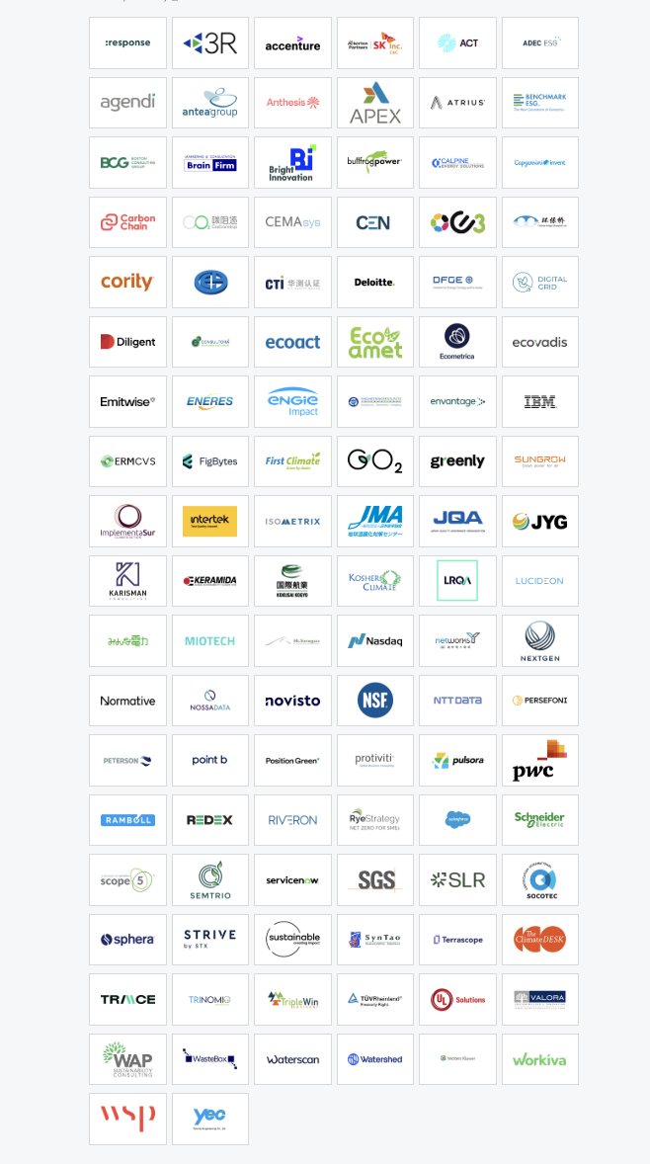The Climate Disclosure Project, on top of research data, economic policy think-thanking, and climate project stewardship, outlines their community partners and resources to encourage team-oriented problem solving. [One provider](https://www.cdp.net/en/partners/pwc) self-described, listed on [CDP’s webpage,](https://www.cdp.net/en/about/collaborations-and-partnerships) as a consultant to ”future-proof” businesses by ”making them more resilient, agile, and sustainable.”  **It is critical to note that majors in the private sector have privileged access to predictive high-quality data analytics that allows dominant competition, and arguably slow-moving responsive climate action.** ***“These experiences providers can help you accelerate your journey in environmental leadership,”***  ***-The Carbon Disclosure Project***

CDP’s annual disclosure deals primarily with voluntary data collection and distribution, the model can be intelligently rethought through other areas of climate organization need. The project’s central procedure for collection and widespread operation is [systematically impressive](https://www.cdp.net/en/articles/companies/cdp-builds-on-success-of-last-years-pilot-to-expand-scope-of-api-in-2024); In a 7-month annual period between Disclosures and Requests, data usage applications *and* contributions are processed before a reset the following cycle. The ongoing exchange between lenders offering information, or ”purchasing” data to compete in a market of climate accountability, is a natural facilitator; As opposed to, a disjointed set of procedures. Company (CDP) values placing transparency, accountability, learned improvement, and cooperative success to be first priority. The organization, recognizing the need to reconcile economy and environment, sees carbon as a form of risk. “We see a tipping point; from transparency to transformation,” (The CDP) **“We need to build back better.”**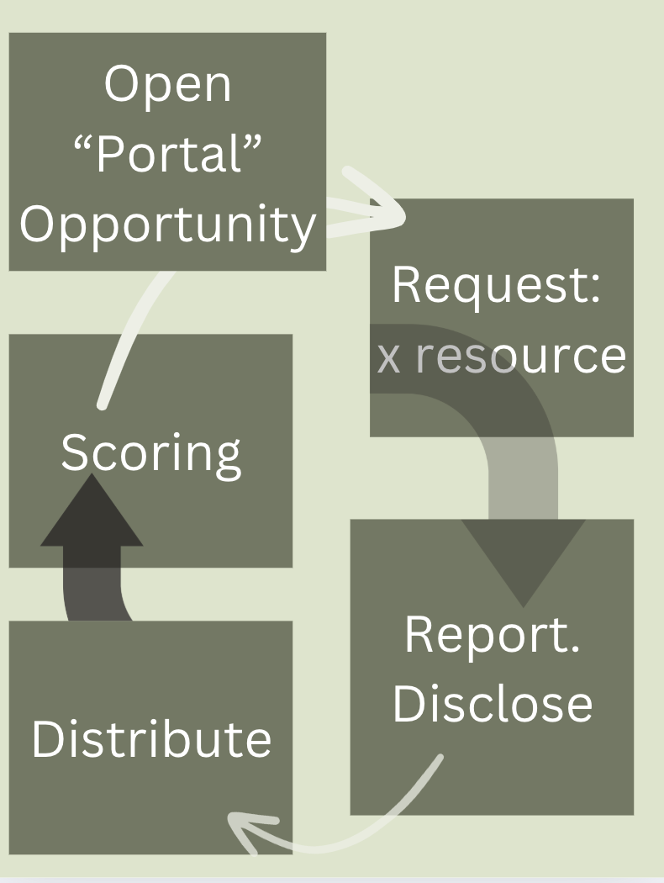

Intellectual architecture in environment work serves as a solid resource to guide smaller-funded governmental, nonprofit, and regional operations--*quite necessarily.* To illustrate, Ohio state governance, contrasting its [Northern neighbor](https://www.michigan.gov/som), lacks overt public mention of climate preparations or environmental concern ([See Ohio.gov](https://ohio.gov/)), where climate issuing is sequestered to Ohio State University’s state climate office of Ohio ([climate.osu.edu](https://climate.osu.edu/)), who’s 2024 report concluded [above normal temperatures.](https://climate.osu.edu/monthly-climate-summary-december-2024) ODOT’s (Ohio Department of Transportation) Resiliency Plan for roadways, bridges, sewerage management systems, likewise, indicated alarming brace vigilance for significant regional weather changes in the short term, mid, and long-term.

The [Ohio Environmental Council (OEC).](https://theoec.org/about-us/) OEC Action Fund lists Climate, Energy, Public Lands, Water, and Community as several of its pillared goals; Tracking federal climate investments, OEC advises to embrace inflation reduction legislation for unilateral community improvement; "These investments [mean] we can lower our home energy costs, upgrade our aging infrastructure, and ensure our communities are resilient to the impacts of climate change” ([theoec.org](https://theoec.org/campaign/federal-climate-investments/)).

1. **Water Scarcity *and* Surplus: An Economic Threat**

**Water risks outlined:** **Physical (water quality, scarcity, flooding, drought)**  **Regulatory (mandated usage restrictions, recycling, conservation, higher water pricing)**  **Reputational (negative stakeholder feedback, lack of support, changing behaviors)**  **Technological (ability to implement water solutions, danger of underprepared** **areas ”left behind”**

**(**[**CDP Water Report, 2022**](https://cdn.cdp.net/cdp-production/cms/reports/documents/000/006/321/original/High_and_Dry_Report_Final.pdf?1651652748)**).**

According to the action group; “grid resilience: [is the] key to a reliable future” ([theoec.org](https://theoec.org/campaign/federal-climate-investments/)). Also, ODOT’s resiliency plan outlines a number of droughts, warming, heavy precipitation, and infrastructural **warnings**:

|  |
| --- |
| Key Lowlights of the Ohio Department of Transportation’s Infrastructure Resiliency Plan (2016, [Read Here](https://environment.transportation.org/wp-content/uploads/2022/03/final_report_odot_infrastructure_vulnerability_assessment_5_6_16.pdf)* Note, this is now several years out of touch with newer climate margins)   * Very likely (>90%) increases in “hurricane intensity” * Likely (>66%) increases in “very hot days” and “heatwaves” * Increasing “extreme rainfall events” * Higher than average temperatures to increase over the 21st century * “For Ohio, evacuations due to flooding and strong winds (i.e tornadoes) are projected to increase” * High likelihood for disruption of storm management systems, flood prone assets (bridges, highways) * Long term threats to emergency operating systems |

Through a digital search, [Columbia Law’s climate change law update platform](https://climate.law.columbia.edu/) (The Sabin Center for Climate Change Law) produced the top cases involving “water” in 2024: Sierra Club v. California Department of Water Resources –private group challenging government water distribution project, Word v. U.S. Department of Energy –lawsuit to encourage water efficiency standards for in-home appliances, and **Board of Lucas County Commissioners v. EPA**. A local case, Lucas County Commissioners, City of Toledo, and Environmental Law & Policy Center v. EPA is moving to amend recent pollutant cap regulation for Lake Erie, on the basis that the writing does not include a “margin of safety” to account for “uncertainties raised by climate change” (Sabin Center, 2024). Worse, plaintiffs argue that the Lakes’ harmful algal bloom is being consistently worsened by climate patterns, threatening water security (Sabin Center, 2024).

**Threats, and reactive policy in *water* regulation, unsustainable pollutants, and “community opposition” were presented by CDP to cause $15.5 billion globally in stranded and at-risk assets** ([CDP Water Report, 2022](https://cdn.cdp.net/cdp-production/cms/reports/documents/000/006/321/original/High_and_Dry_Report_Final.pdf?1651652748)); CDP’s 2021 data set, predicts: 44% potential impact for reduction in production capacity, 24% increased operating costs, 9% supply chain disruption, and 8% operation closures (CDP Water Report, 2022).

In order of hardest hit, manufacturing, materials, infrastructure, and food beverage/agriculture industries reported some closures of operations ([CDP Water Report, 2022](https://cdn.cdp.net/cdp-production/cms/reports/documents/000/006/321/original/High_and_Dry_Report_Final.pdf?1651652748)); while these areas each moderate likelihood for supply chain disruptions that would alter operations ([CDP Water Report, 2022](https://cdn.cdp.net/cdp-production/cms/reports/documents/000/006/321/original/High_and_Dry_Report_Final.pdf?1651652748)). 69% of CDP respondents are exposed to **significant** water-related risks, and the UN predicts a **40% global shortfall in water supply** **by 2030** given the current, persistent consumption behaviors of consumers. Bowling Green sources its water from the Maumee River, [reported in 1996](https://www.in.gov/dnr/water/files/maumee_basinsums.pdf) by Indiana authorities to benefit from “absence of a dry season-” a changing fact ([see Part A for broader environmental hazards](https://falconbgsu-my.sharepoint.com/:f:/g/personal/gasserh_bgsu_edu/EuY8GB07MrhCq6Hs3k6EVsgBS7roUnSpJY7WuknF0t2yOw?e=IejhBf)). Aligned with other local policy, the BG Utilities Department publicly lists a water boil advisory, sewer backflow prevention, and wet-basement prevention as baseline actions considered for *mild* water crises. Perhaps the most proactive example for communal water-project initiative shines in the city’s Clean Water Removal Program: “offering financial assistances for residents that wish to help in reducing combined sewer overflowed...[by] disconnecting clean water connections to the combined and sanitary sewer, such as gutter downspout and sump pump removal (rain and ground water)” ([BGohio.org](https://www.bgohio.org/667/Back-Flow-Prevention)). According to the city, under back-flow and contamination prevention, local water consumers “have the ultimate responsibility for maintaining their plumbing systems” ([BGohio.org](https://www.bgohio.org/667/Back-Flow-Prevention)).

1. **Solutions in Bowling Green, OH**

Geographic regions built on clay soils--such as Ohio, will have a worse time with heavy precipitation (ODOT, 2016), given this soil type’s low permeability (ODOT, 2016).

Reminder: in bootstrap economic and civilian life policy, emphasis on public participation indicates future gaps requiring fill between government provisions. I see this as perfect positioning for empowered community members taking action. I also see this as a threat to administrative actors getting a hold on sheparding their people into better times of innovative sustainability building.

|  |
| --- |
| Key Lowlights of the Bowling Green Department of City Sustainability’s Climate Resiliency Plan (2024, [Read Here)](https://www.researchgate.net/publication/382387611_City_of_Bowling_Green_Ohio_2024_Climate_Action_and_Resiliency_Improvement_Plan)   * “Midwest U.S. will experience potentially devastating impacts from increases frequency and magnitude of flooding, droughts, storms, and extreme heat events Flooding will affect infrastructure, health, agriculture, forestry, transportation, and water quality--” BG’s water supply is susceptible to droughted conditions * “At this time, it is not possible to achieve net zero carbon emissions solely through changes in power supply portfolio” * BG water supply is susceptible to drought, at length * **Public buildings as “resiliency centers.” Should be flood proof, have weather shelters, cooling centers for heat waves or warming during Winter... ability to provide water, food, rudimentary medical attention for large groups of people”** * Primary dedication to education and outreach, rather than marked projects or changes (the [BG City](https://www.bgohio.org/) groups sustainability under communications, in low prioritization). |

The City of Bowling Green’s own project managers advised hiring an “energy consultant” to manage power grid changes; at this time, wind and solar are young, and systemically unreliable to manage our area’s demand. Hydroelectric—procedure allowing energy to generate from flowing water—is produced via 6 dam holdings in BG. The six measures listed for stormwater management are as follows:

1. Public Education
2. Public Participation and Involvement
3. Illicit discharge detection and elimination
4. Construction site runoff control
5. Post-construction runoff control
6. Pollution Prevention Control

(City of Bowling Green, 2024)

***Furthermore,***

***“BOWLING GREEN CAN MAKE SIGNIFICANT PROGRESS TOWARD NET ZERO EMISSIONS BY IMPROVING THE ENERGY EFFICIENCY OF MOST GOVERNMENT BUILDINGS, [NEW ADMIN BUILDING IS ALREADY EFFICIENT, EXAMPLE OF SUCCESS;”***

1. **The CCC Garden: Communal Climate Charge Garden**

Combined with the water cooling and technology from part A, informed gardening building poses one of the best intersectional solutions for Bowling Green’s own climate action plan. Thus, we turn to the invention and creativity beholden by the nonprofit sector in times of administrative, governmental failure (as opposed to last installations emphasis on private tech).

***Now, facing the water management puzzle, predicted worsening air quality (ODOT, 2016), and levels separating player responsibilities, I visit Green Space as a solution.***

—  **An example of the relationship I witness between plant life, beauty, and human infrastructure in Austria. Coming back to the United States was tough.** 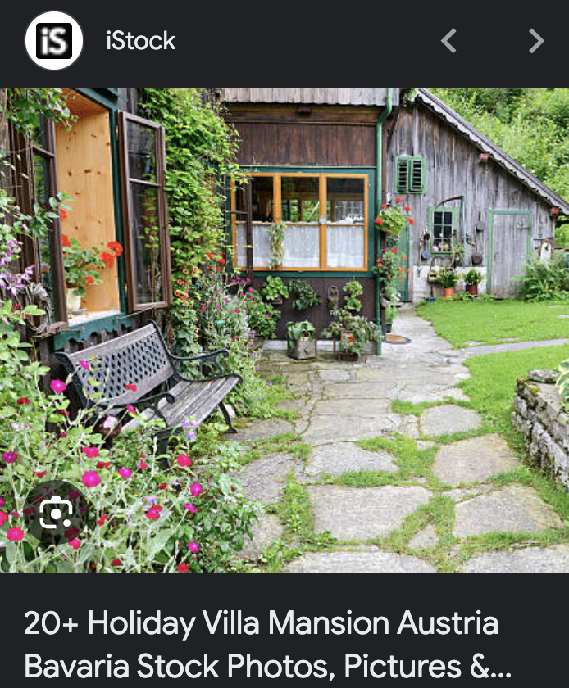

Green Space

“Green space,” as my concept, is organic plant life that is **self-sustaining**; ecosystematically intact without interventionalism. The rain garden can be defined as plant varieties planted in-ground, in larger batches, with purpose to temporarily **store storm water**, often too providing pollinator habitats. Community gardens are domestic planting and harvesting projects; Plants are assigned to produce **food**. “[Managed natural landscapes](https://www.bgohio.org/679/Managed-Natural-Landscapes)” (bgohio.org) can include varieties of mixed grasses, without harmful or unpleasant weeds

Gardens, then, serve many functions. Bowling Green City says, ***“managed rain gardens reduce the amount of stormwater and runoff entering the storm sewer system,” -*** [***BG CITY.***](https://www.bgohio.org/662/Rain-Gardens)**Proposed garden projects**must**:** improve stormwater retention, increase water quality and biodiversity of wildlife and *beneficial species.*

Biodiversity of species is also a bonus, with [sensitive regard, though, to humans boasting some natural plant varieties over nonnative species that might survive intemperate atmospheric conditions.](https://www.xerces.org/blog/for-wildlife-and-humans-native-plants-are-key-to-climate-resilience) Native plants, typically, are supported to uphold regional uniqueness and local wildlife habits.

|  |
| --- |
| Green Space Highlights of Bowling Green City Vulnerability Assessment (2024)   * Green spaces as Carbon sinks. “Restored wetlands have been shown to be very significant carbon storage components.” * “Promote infiltration of rainwater (reducing urban flooding)” * Improving health and psychological well-being of community <3 awh! * Transitioning high-maintenance, non-native turf areas to low-maintenance, native areas to meet sustainability goals and initiatives. “Low maintenance, native vegetation provides numerous environmental * The City tentatively (boo) plans to install [Bioswales to mitigate water runoff issues.](https://www.esf.edu/ere/endreny/GICalculator/BioswaleIntro.html#:~:text=What%20is%20a%20Bioswale%3F,%22%20or%20%22filter%20strips.%22) |

1. **TURNING TO PRIVATE SECTOR AND NONPROFIT IN TIMES OF ADMINISTRATIVE, GOVERNMENEAL FAILURE**

**The Bowling Green Save Our Neighborhoods Group (B.G. SONG)**

B.G. SONG, a 510c3 nonprofit, initiated in the Winter of 2022 from a “B.G. STRONG” zoning activism project, has since evolved to reflect the multifaceted interests of protecting local community values.

Through a longer conversation on the relations between the local administrations and other actors, SONG’s founders voiced the importance of SONG’s focused facilitation, where University and City officials have been keyed in on otherwise unexpected project collaboration. *Rock the Block* was one example.

[*SONG President] “*The City and the University worked together. That’s something they hardly ever do.”

[*SONG Co-Founder] “*It could be a healthier and more productive relationship.”

As SONG continued to expand, the Board organized *Community Call to Action* sessions, resulting in the 4 operating pillars of the 2024 Strategic Plan: climate change preparation, housing revitalization, transportation mechanisms, and new housing. The sustainability group has tiers of immediate plans and tasks, adjacent to developing climate impact goals. David proposed several in-progress technological solutions to flooding, such as permeable driveways and City budget allocation for routine asphalt replacements. SONG is also currently working on natural remedies.

*[SONG CO-Founder] “*We want to support the urban forester in being able to increase the tree canopy, and we want to support the Parks & Recreation’s naturalist to encourage people to plant native [plants, species].”

Responding to my request for a glance at the [Part A submission](https://falconbgsu-my.sharepoint.com/:w:/g/personal/gasserh_bgsu_edu/EcfgQVS9wE1BnjMh8gZCZYMBk7zYv3XD3s8uC16N_5dCgw?e=2Uh2pG), the founders provided generous feedback.

* Mr. Drain, a trained industrial engineer, recalled a large factory building with a ‘smart roof’ of sorts in the Wood County region. Certain heavy, complex technology may not be plausible to apply to an existing building.
  + *“Can the structure handle something like that?”*
  + *[Mr. Drain] “*Everything comes down to cost. If it required no retrofitting, yes.”
* The City has moved to seek replacing dark colored roofs for heat absorption issues
  + For any City project, cutting utility costs and reducing negative environmental symptoms can exist in private, or publicly owned, property upkeep.
* In the discussion of community gardening, beware of the Tragedy of the Commons.
  + *[Mrs. Drain] “*The City will be wary.”
  + According to Rose, Simpson’s Gardens saw a decline of volunteer participation after early motivations tapered off.

**CONCLUSION**

Proactivity, as opposed to passivity or reactive budgeting, saves life, human society’s creations, and normalcy. The solutions can and should vary depending on locations’ preferences, ability, and demographics.

The methods and models devised by experts beyond me must be learned and shared to not simply address political amplification of a climate crisis, but reclaim connectivity with the lands that used to thrive naturally. The largest manufactured problem that people find with sustainability projects is financial pushback, that which has been address to the heart in this piece. The Economist model can be applied to the case in Bowling Green. An economic process for climate finance could look like:

1. Amount of public money necessary to spark enough private investment in renewable energy
2. Compensation paid to those losing opportunity due to transitions, i.e., fossil fuel mitigation or forest preservation cutting industries.
3. Adaptation funding: “to cope with a warmer planet.”

\**Excluding adaptation funding cleans budget.* (The Economist, 2, 2024)

***“*What we would like is for Bowling Green to be a forward-looking community, rather than a community that is satisfied with ‘things as they are.’”**

***-Rose Drain, Bowling Green Save Our Neighborhoods Group***

*In Conclusion: Let’s Do More, Together. References*:*

*Most links are cited here. If not cited, the link is supplementary and was not consulted to a degree, or of research caliber, to be listed here.*

𓇢𓆸 Carbon Disclosure Project (CDP), Van Staden, M., & Kutner, M. (2022). Protecting People and the Planet: Putting people at the heart of city climate action. In CDP. <https://cdn.cdp.net/cdp-production/cms/reports/documents/000/006/567/original/CDP_Cities_Protecting_People_and_the_Planet.pdf?1665068434>

# 𓇢𓆸 Gamby, A. et. al., (2024) City of Bowling Green, Ohio 2024 Climate Action and Resiliency Improvement Plan.

<https://www.researchgate.net/publication/382387611_City_of_Bowling_Green_Ohio_2024_Climate_Action_and_Resiliency_Improvement_Plan>

𓇢𓆸 United Nations Framework Convention on Climate Change ([UNFCCC](https://unfccc.int/this-site/terms-of-use)).

𓇢𓆸 DeConcini, C., Rennicks, J., & Hyman, G. (2024, November 13). *Trump May Thwart Federal Climate Action, but Opportunities for Progress Remain*. World Resources Institute. <https://www.wri.org/insights/trump-climate-action-setbacks-opportunities-us>

𓇢𓆸 The Economist (1). (2024). *How to pay for the poor world to go green*. The Economist. <https://www.economist.com/finance-and-economics/2024/11/14/how-to-pay-for-the-poor-world-to-go-green>

𓇢𓆸 The Economist (2). (2024). *The energy transition will be much cheaper than you think*. The Economist. <https://www.economist.com/interactive/briefing/2024/11/14/the-energy-transition-will-be-much-cheaper-than-you-think>

𓇢𓆸 *The Ohio Environmental Council (OEC)* (n.d.). Ohio Environmental Council. <https://theoec.org/>

𓇢𓆸 *Federal Climate Investments*. (2024, September 27). Ohio Environmental Council. <https://theoec.org/campaign/federal-climate-investments/>

𓇢𓆸 *Ohio Climate Change Resources | State Climate Office of Ohio*. (2021). Osu.edu. <https://climate.osu.edu/ohio-climate-change-resources>

𓇢𓆸 *OHIO DOT (ODOT) INFRASTRUCTURE RESILIENCY PLAN OHIO DEPARTMENT OF TRANSPORTATION SUBMITTED BY: RSG*. (2016). <https://environment.transportation.org/wp-content/uploads/2022/03/final_report_odot_infrastructure_vulnerability_assessment_5_6_16.pdf>

𓇢𓆸 Gamby, A., Bechstein, M., Evans, J., & Hennessy, N., et.al (2024). 2024 Climate Action and Resiliency Improvement Plan [Review of *2024 Climate Action and Resiliency Improvement Plan*]. In *bgohio.com* (pp. 1–70). City of Bowling Green, OH. https://www.bgohio.org/DocumentCenter/View/4893/2024-Bowling-Green-Climate-Action-and-Resiliency-Improvement-Plan-8-5-2024-PDF?bidId=  
Prepared by the BG City Climate Action Planning Committee

𓇢𓆸 *Northwest (NW) Ohio Housing*. (2021). Nwohhousing.org. <http://www.nwohhousing.org/bowlingGreen.aspx>

𓇢𓆸 *Bioswales*. (n.d.). College of Environmental Science and Forestry (ESF) [Www.esf.edu](https://Www.esf.edu). [https://www.esf.edu/ere/](https://www.esf.edu/ere/endreny/GICalculator/BioswaleIntro.html)endreny/GICalculator/BioswaleIntro.html

𓇢𓆸 *Charity Commission for England and Wales.* Register of Charities. Charitycommission.gov.uk.

<https://register-of-charities.charitycommission.gov.uk/en/charity-search/?p_p_id=uk_gov_ccew_onereg_charitydetails_web_portlet_CharityDetailsPortlet&p_p_lifecycle=0&p_p_state=maximized&p_p_mode=view&_uk_gov_ccew_onereg_charitydetails_web_portlet_CharityDetailsPortlet_regId=1122330&_uk_gov_ccew_onereg_charitydetails_web_portlet_CharityDetailsPortlet_subId=0>

𓇢𓆸 The Climate Disclosure Project. *“High and Dry: How Water Issues Are Stranding Assets.”* <https://www.cdp.net/en/research/global-reports/high-and-dry-how-water-issues-are-stranding-assets>

𓇢𓆸 The Ohio State University (2024, December 1). *Monthly Climate Summary: December*  *2024*. State Climate Office of Ohio. Retrieved January 1, 2025, from <https://climate.osu.edu/monthly-climate-summary-december-2024>

𓇢𓆸 WRI (2024, November 13). *Trump May Thward Federal Climate Action, but Opportunities for Progress Remain*. World Resources Institute. Retrieved January 1, 2025, from <https://www.wri.org/insights/trump-climate-action-setbacks-opportunities-us>

𓇢𓆸 OEC (n.d.). *How the Inflation Reduction Act and the Bipartisan Infrastructure Law are Supporting a Healthier Environment for All Who Call Ohio Home*. The Ohio Environmental Council. Retrieved January 1, 2025, from <https://theoec.org/campaign/federal-climate-investments/>

𓇢𓆸 The Ohio State University (n.d.). *Ohio Climate Change Resources*. State Climate Office of Ohio. Retrieved January 1, 2025, from <https://climate.osu.edu/ohio-climate-change-resources>

𓇢𓆸 (2016). Ohio DOT Infrastructure Resiliency Plan. *RSG, The Science of Insight*. <https://environment.transportation.org/wp-content/uploads/2022/03/final_report_odot_infrastructure_vulnerability_assessment_5_6_16.pdf>

𓇢𓆸 The Sabin Center (n.d.). *U.S. Climate Change Litigation*. Columbia Law School | Columbia Climate School Sabin Center For Climate Change Law. Retrieved January 1, 2025, from <https://climatecasechart.com/us-climate-change-litigation/>

𓇢𓆸 (2024). *2024 Climate Action and Resiliency Improvement Plan*. City of Bowling Green, Climate Action Planning Committee. <https://www.bgohio.org/DocumentCenter/View/4893/2024-Bowling-Green-Climate-Action-and-Resiliency-Improvement-Plan-8-5-2024-PDF?bidId=>